QS11.1

Hotel Warehouse

320 miles

GP1

**Hotel** **Warehouse**

432 miles

QS11.2

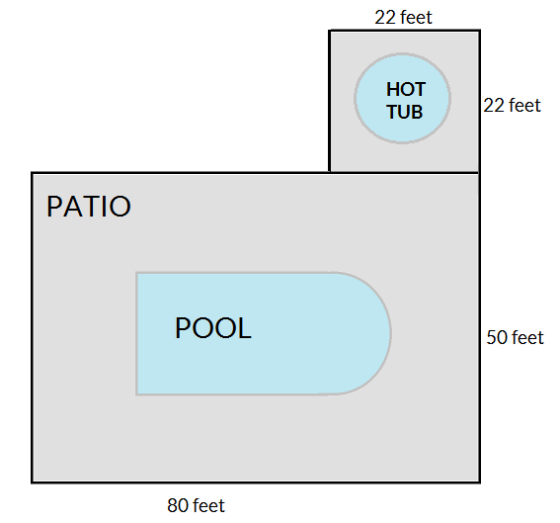

Shared fencing

Square

Rectangle

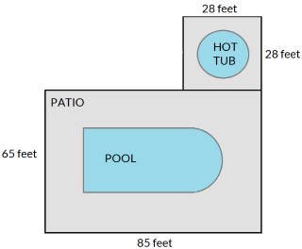

Shared  
fencing

Rectangle

Shared fencing

Square

GP1

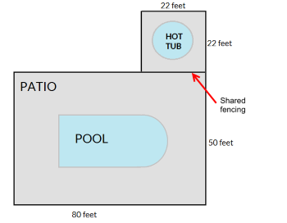

Square

Shared fencing

Rectangle

GP3

25 yards

25 yards

Shared fencing

Garden

Garden

20 yards

20 yards

Compost

Compost

5 yards

5 yards

5 yards

5 yards

25 yards

Garden

Garden

20 yards

20 yards

20 yards

5 yards

5 yards

Compost

Compost

5 yards

5 yards

GP2

10 feet

MAIN SECTION

8 feet

14 feet

ALCOVE

8 feet

LIVING ROOM

10 feet

MAIN SECTION

8 feet

14 feet

ALCOVE

8 feet

Shared portion with no wall

LIVING ROOM

Shared portion with no wall

Rectangle

Square

10 feet

14 – 8 = 6 feet

14 feet

8 feet

MAIN SECTION

8 feet

ALCOVE

8 feet

10 feet

QS 11.3 Overview and GP1.   
  
See png file for replacements, and the site as well. GP2 and 3 graphics are in a separate document.

?

AREA

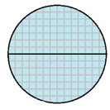

DIAMETER

RADIUS

RADIUS

LENGTH

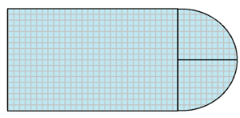

Replaced

WIDTH



Replaced

14 feet



30 + 10.5 = 40.5 feet

18 feet

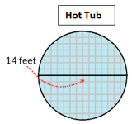

radius = 7 feet

11.4 and 11.5 All graphics in separate documents